Steven Cannon

Kyndryl/IBM Contractor

Identity Provisioning Teams – L3 Engineer

Abstract

Support Items related to eReg & Domino

Domino eReg

Support Cookbook

Table of Contents

**Domino eReg Support Cookbook 2**

Databases Involved in Support 2

Password Resend (PW) Support 2

Add Users (AU) Support 3

Other Types of eReg Requests 4

Restore User Support 4

Pre-Requisites to do a Restore 4

Ready to Restore 4

Monitor the Restore 5

**Domino eReg Support Cookbook**

Databases Involved in Support

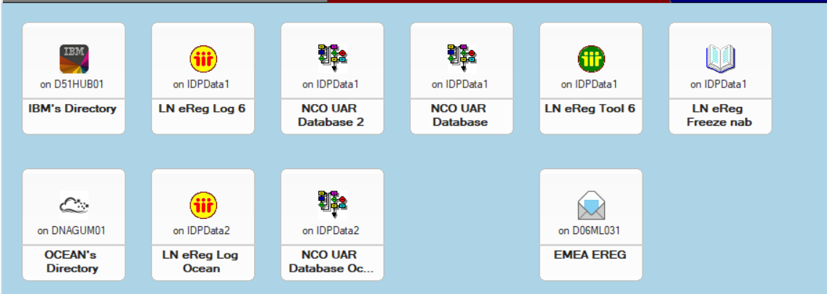

* Row 1 is IBM Databases
  + IBM’s Directory – D51HUB01/51/H/IBM – File Name – Names.nsf
  + LN eReg Log 6 – IDPData1/IDP – File Name – eRegLog6.nsf
  + NCO UAR Database 2 – IDPData1/IDP – File Name – e_dir\ncouar2.nsf
  + NCO UAR Database – IDPData1/IDP – File Name – e_dir\ncouaruk.nsf
  + LN eReg Tool 6 – IDPData1/IDP – File Name – e_dir\eregtoo6.nsf
  + LN eReg Freeze NAB – IDPData1/IDP – File Name – n_dir\freeze.nsf
* Row 2 is Ocean Databases (First 3)
  + Ocean’s Directory – DNAGUM01/H/Ocean – File Name – names.nsf
  + LN eReg Log Ocean – IDPData2/IDP – File Name – ocean\eregLog6.nsf
  + NCO UAR Database Ocean – IDPData2/IDP – File Name – ocean\ncouar3.nsf
* Row 2 Far Right DB
  + EMEA EREG – D06ML031/06/M/IBM – File Name – mail04\DETE0035.nsf

Password Resend (PW) Support

* There are multiple ways that a PW request can be sent into eReg. They can be done via an ASO Backend Request for PW. It can also come via ISIM under the credentials tab.
* If the issue you are getting is that the email is not being received by the end user, then you can test the process via ISIM by doing a resend credentials on yourself and verify if you can receive the email yourself. If you are not getting the email either, then contact L3.
* Other potential issue is that the user is getting the email, but it is encrypted. You will have to look in the log file for the PW Request and see where the credentials were emails, and it should show if it was encrypted or not. The mail send line in the log should look like this – “*IBM Confidential: Lotus Notes Password for TheGuide Librarian send unencrypted ==> John Schreck/Fishkill/IBM@IBMMAIL”. If you see in that line that it is encrypted, then contact L3 team so they can resolve.

Add Users (AU) Support

* AU’s or Add Users is a process to create a new account for a user in our CIO Systems. Most AUs are initiated outside of Domino eReg. There is an ASO Backend Request for an AU, but you will need to go through L3 team to get one of those initiated. This section will focus on dealing with an AU request once it is in eReg.
* New/Pending AUs are most likely just waiting to be run so you can just wait. But if an AU in either status has been sitting there for over 48 hours you will need to go to L3 team to have them investigate it. If is it in a pending status for over 48 hours, it may have run at least once already and have an error message. You can find those that do by looking into the Pending by Errors view or opening any pending AUs and seeing if there is an error message in the log.
* AdminP AUs, AdminP is the various steps/processes that an AU goes through in eReg. Typically issues around AU’s are when they are in AdminP-01 status.
  + Mail Server not setup. If you look at the bottom of the log file and see the following line – “Add-user process pending because template is not replaced: MailServer = PO Mailfile= “ and this most likely means that the Mail Server for the user has not been set in the NAB. For Ocean users there is a process that runs daily to set the mail server names. You can find this agent in Last Actions by Agent, then collapse the view, then expand the entry for AssignOceanMailFilest. You can search inside there for short name or full name of the user you are looking for to see if the mail server has been set. If it has been set, then next time eReg loops through the request it should complete the processing. If the log file is still getting an error or not showing the updated mail server then contact L3 team. For IBM Users there is a process but not trackable like they are in Ocean eReg Log. If the mail server is not getting set for 24-48 hours, then contact L3 team.
  + Strange Server Error. This one can fall back as Mail Server not setup as well. You will need to look at the log file and scroll to the bottom and look for the error in the most recent run of the process to determine.

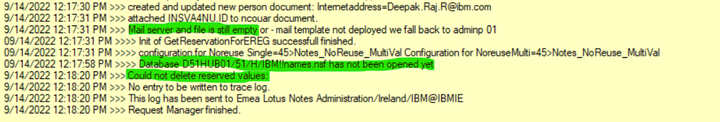

* + - As you can see in the above log entry there is an issue with “Mail Server and file is still empty” and “Database D51HUB01/51/H/IBM!!names.nsf has not been opened yet” and “Could not delete reserved values”. In looking at this first thing I would look at verifying is if the name.nsf file could be opened directly on the D51HUB01 server. If it could then I would restart the request in eReg Log and see if that clears up any issues. If getting that part cleared up still did not resolve the issue, then I would contact an L3 about getting the Mail Server and Mail File names setup and once that is done restart the process. If the last issue is the only issue you see about the reserved values, then get with the L3 team about that so they can check the reservations databases.
  + If you are seeing other types of errors tied to an AdminP AU Request best idea would be to contact the L3 team with the issue.

Other Types of eReg Requests

* Types – Alias Change (AC), Change Person (CP), Delete User (DU), HR Batch (HR), Kill User (KU), Rebuild ID (RB), Rename (RN), Resume (RS), Revoke (RV)
* Most all instances of issues you have in here will require L3 support to resolve. You can look at the log file first for the error or scroll down to the bottom of the log file. Unable to open DB’s or servers like above, or you might see something like “nab: Could not open names.nsf on D03DAAT2” would be the same thing, so let the L3 team know so they can setup connectivity to the server by updating the IP addresses on the hosts files of the local eReg machines.

Restore User Support

* Restores are done on user accounts that have been deleted, but the mailbox has not yet been removed.
* Pre-Requisites to do a Restore
  + Ocean’s Directory or IBM’s Directory (Based on which side doing restore) – Verify that the user is not in the NAB by searching via full name, short name, or email address. If the user has a document/record in the NAB then a restore cannot be done, contact L3.
  + NCO UAR Database Ocean or NCO UAR Database 2 (Based on which side doing restore) – Look in the Deleted by views to see if the user has a record there. Such as Deleted by Short Name. You must find a match for the user in the Deleted views for the Restore to Work. If no match is found then a restore cannot be done, contact L3.

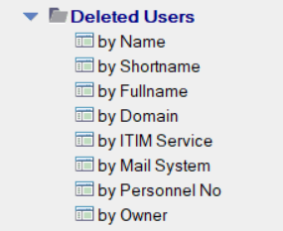

* + Deny Access Group View – In appropriate directory for whichever side (Kyndryl/IBM) you are looking to do a restore for. In NAB open Groups section and choose Deny Access Groups. Then in top menu under view click on Search this view. Type in username to search and search the view. If a match is found, you can proceed with restore. If a match is not found, check with L3 to see if you can still do the restore.

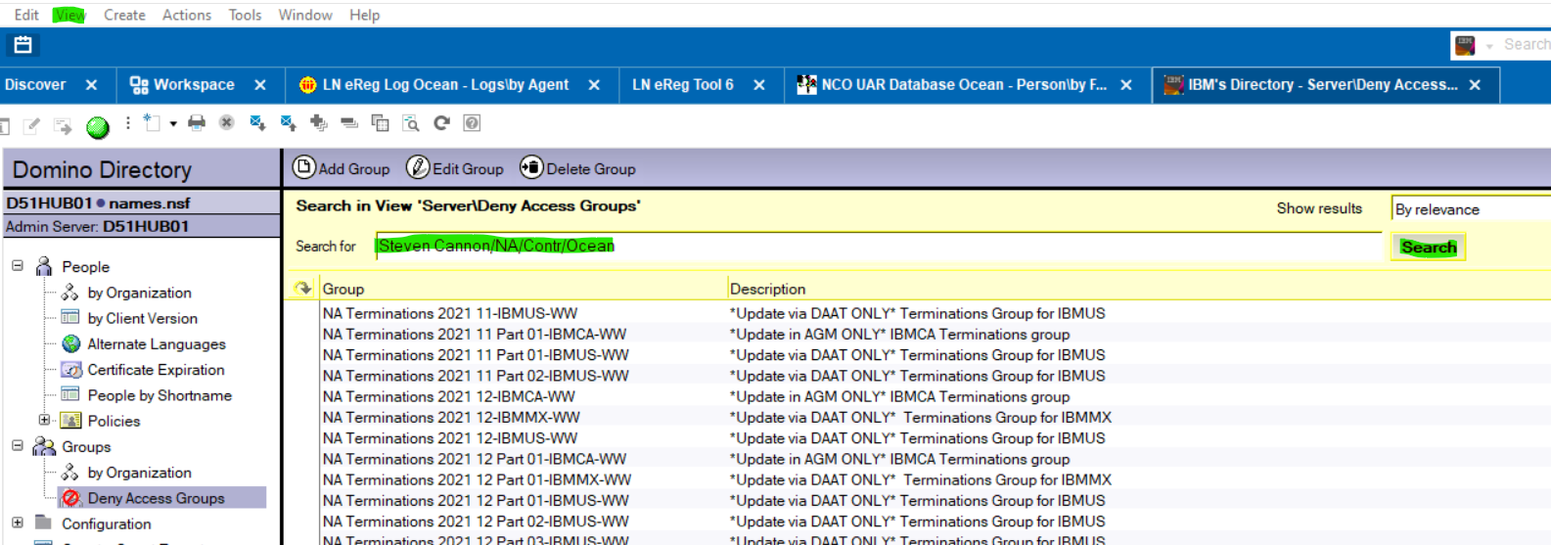

* + LN eReg Freeze NAB – Search a view in here to verify if the user’s record is in there. If there is no record in here the Restore will not work, check with L3.
  + 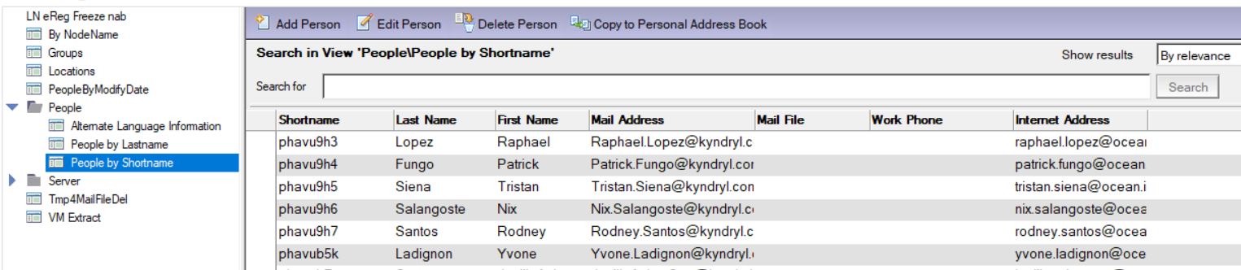
* Ready for Restore
  + If the NCOUAR Document is in Deleted or Out Status and the NAB is empty of a person record and there is an entry in the Freeze NAB. Then contact L3 team to do a restore for you.
  + You can monitor the restore once it has been submitted by L3 team to the EMEA eReg mailbox in the appropriate eReg Log Database for the side the restore is for (IBM/Kyndryl).
* Monitor the Restore
  + Open the appropriate eReg Log Database.
  + Go to Last Actions by Agent view. Collapse the view, then expand the section for “UpdateIDs”

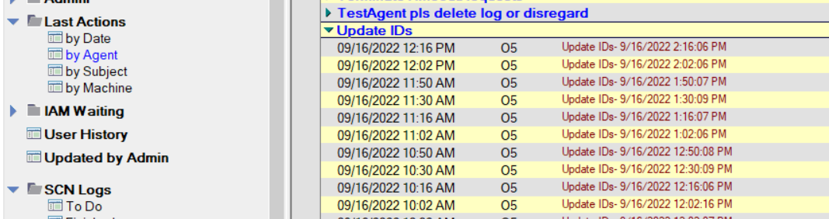

* + Look for the entry from 15-20 minutes after the Restore was submitted by L3 team member.
  + Open the log file and you are looking for the short name that matches up with your request. Then look through the log file to verify that it was copied back from Freeze NAB to NAB Successfully. Also verify that NCOUAR document was put back to active and a mail was sent to the DAG tool.

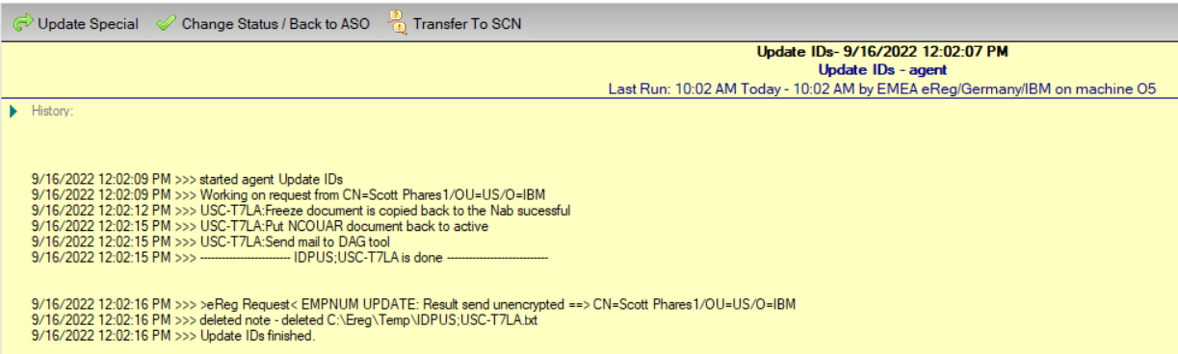

* + At this point you should be able to see the various documents from NCOUAR & NAB back in their respective places (Active by Short Name in NCOUAR DB & back in the regular NAB as well).